**Part 1**

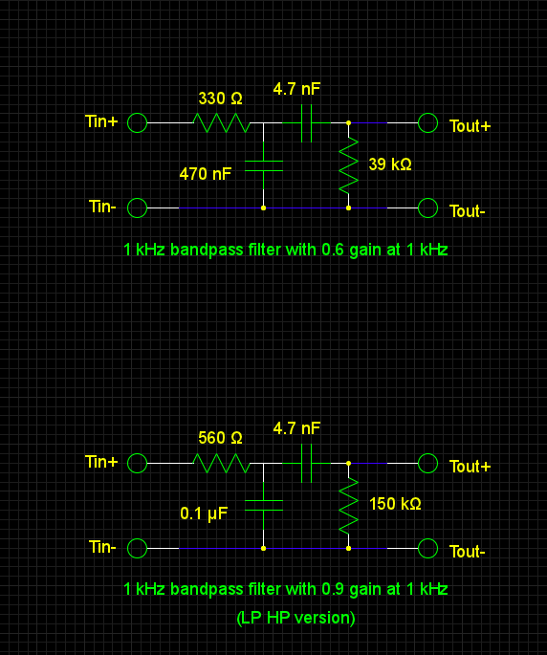

**Lopass->Hipass vs Hipass->Lopass**

Lowpass driving highpass has a better ratio of input impedance to output impedance.

Q = 1000 / (3200-200) = .3

Q = 1000 / (2200-400) = .56

**Part 2**

**IA. Halfwave Rectifier**

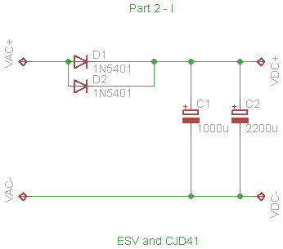

|  |  |  |  |  |
| --- | --- | --- | --- | --- |
| Output Current | Output Voltage | P-P Ripple | Peak Current (Secondary) | R |
| 0.053 | 14.06 | 0 | 0.085 | Inf |
| 0.501 | 12.3 | 2.05 | 3.5 | 25 |
| 1.02 | 11.5 | 4.2 | 6.5 | 12 |
| 1.588 | 10.6 | 6.5 | 9.4 | 7 |
| 2.07 | 9.86 | 8 | 11.6 | 4 |

Halfwave rectifier data

**B Fullwave Rectifier**

|  |  |  |  |  |
| --- | --- | --- | --- | --- |
| Output Voltage | Output Current | P-P Ripple | Peak Current (Secondary) | R |
| 13.812 | 0.088 | 0 | 0.093 | 100k |
| 12.009 | 0.566 | 0.5 | 1.8 | 25 |
| 11.68 | 1.017 | 0.9 | 1.82 | 12 |
| 11.264 | 1.575 | 1.3 | 1.82 | 7 |
| 10.702 | 1.813 | 2.1 | 1.82 | 4 |

Fullwave rectifier data

**II Voltage Doubler**

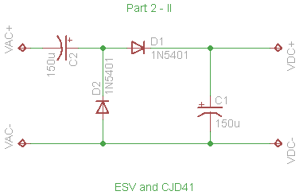

|  |  |  |  |  |  |
| --- | --- | --- | --- | --- | --- |
| Condition | Output Voltage | Output Ripple | Output Current | R | Ripple % |
| NoLoad;115VAC | 28.405 | 0.76 |  | 10M | 3% |
| FullLoad;115VAC | 24.7 | 2.4 | 0.049 | 480 | 10% |
| FullLoadR;95VAC | 20.3 | 2.1 | 0.0418 | 480 | 10% |
| FullLoadI;95VAC | 19.6 | 2.5 | 0.0494 | 389 | 13% |
| FullLoadR;130VAC | 27.7 | 3.2 | 0.056 | 480 | 12% |
| FullLoadI;130VAC | 27.8 | 3 | 0.0495 | 550 | 11% |

**III Regulated Voltage Doubler**

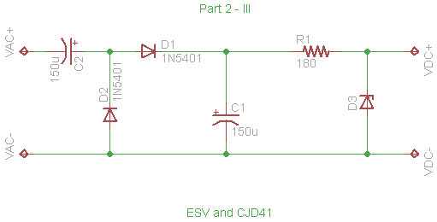

|  |  |  |  |  |  |
| --- | --- | --- | --- | --- | --- |
| Condition | Output Voltage | Output Ripple | Output Current | R | Ripple % |
| NoLoad;115VAC | 13.1 | 0.1 | 0 | Inf | 1% |
| FullLoad;115VAC | 12.2 | 0.1 | 0.043 | 267 | 1% |
| FullLoadR;95VAC | 11.8 | 0.4 | 0.042 | 267 | 3% |
| FullLoadR;130VAC | 12.6 | 0.1 | 0.044 | 267 | 1% |